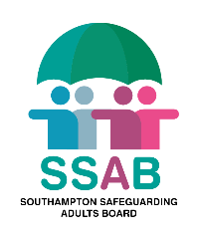
Our Safeguarding Strategy
2021-2024
Consultation Response

The Southampton Safeguarding Adults Board has published “Our Safeguarding Strategy 2021-24”.
We are keen to know a range of views and we are asking three very straightforward questions.
You can send your responses to the questions below to the Safeguarding Adult Board at lsab@southampton.gov.uk. Please send responses by 23rd April 2021.

Question 1: The Safeguarding Priorities set out in our Strategy for Southampton were chosen by our Safeguarding Adult Partnership from across our City. Do you think we have got them right? If so why ? If not why?
Question 2: How can you help the Safeguarding Adults Board achieve it’s priorities?
Question 3: Do you have any further comments?

